العـنـوان باللغة العربية (الخط: Sakkal Majalla ، حجم الخط 16، تباعد أسطر 1,0)
¹الإسم الكامل للباحث الأول* ، ²الاسم الكامل للباحث الثاني
¹مؤسسة الإنتماء (البلد)، ²مؤسسة الانتماء (البلد)
Title in English (Sakkal Majalla; size-16; Interline 1.0)
¹Full name of the first author* ,² Full name of the second author
¹ ORCID: , ² ORCID:
¹Full affiliation (Country), professional e-mail of researcher
²Full affiliation (Country), professional e-mail of researcher
(Sakkal Majalla 14, interline 1.0)
Received: ... /… /2025 Accepted: ... /… /2025 Published: ... /… /2025

الملخص: ) 150 – 250 كلمة) (الخط: Sakkal Majalla ، حجم الخط 14، تباعد أسطر (1,0
ضع الملخص هنا (يتم الإشارة في الملخص إلى هدف البحث، وأهم النتائج المتوصل إليها في فقرتين). ضع الملخص هنا (يتم الإشارة في الملخص إلى هدف البحث، وأهم النتائج المتوصل إليها في فقرتين).
كلمات مفتاحية: ك. م.، ك. م.، ك. م.، ك. م.، ك. م.
Abstract: (150-250 words) (Sakkal Majalla; size-14; Interline 1,0)
Enter your abstract here (an abstract is a brief, More importantly comprehensive summary of the contents of the article). Enter your abstract here (an abstract is a brief, More importantly comprehensive summary of the contents of the article).
Keywords: keywords; keywords; keywords; keywords; keywords.

INTRODUCTION
The first subtitle opens with an introduction that presents the specific problem under study and describes the research strategy. The first subtitle opens with an introduction that presents the specific problem under study and describes the research strategy. (Sakkal Majalla14, interline 1.0)

Chapter I: Title
First main title: First Subtitle
Enter here the text of first subtitle, Enter here the text of first subtitle, Enter here the text of first subtitle, Enter here the text of first subtitle, Enter here the text of first subtitle, Enter here the text of first subtitle, Enter here the text of first subtitle. (Sakkal Majalla14, interline 1.0)
Second main title: Second Subtitle
Enter here the text of second subtitle, enter here the text of second subtitle, enter here the text of second subtitle, enter here the text of second subtitle, enter here the text of second subtitle, enter here the text of second subtitle, enter here the text of second subtitle. (Sakkal Majalla14, interline 1.0)
Chapter II: Title
First main title: First Subtitle
Enter here the text of first subtitle, Enter here the text of first subtitle, Enter here the text of first subtitle, Enter here the text of first subtitle, Enter here the text of first subtitle, Enter here the text of first subtitle, Enter here the text of first subtitle.
Second main title: Second Subtitle
Enter here the text of second subtitle, enter here the text of second subtitle, enter here the text of second subtitle, enter here the text of second subtitle, enter here the text of second subtitle, enter here the text of second subtitle, enter here the text of second subtitle, enter here the text of second subtitle, enter here the text of second subtitle.

Table 1. Table title (this is an example of table 1)
Test 1 | Test 2 | Results 1 | Results 2 | Total Results
15.21 | 15.21 | 15.21 | 15.21 | 15.21
18.58 | 18.58 | 18.58 | 18.58 | 18.58
11.14 | 11.14 | 11.14 | 11.14 | 11.14
Source: author’s name, year, page

Fig.1. Figure title (this is an example of figure 1)
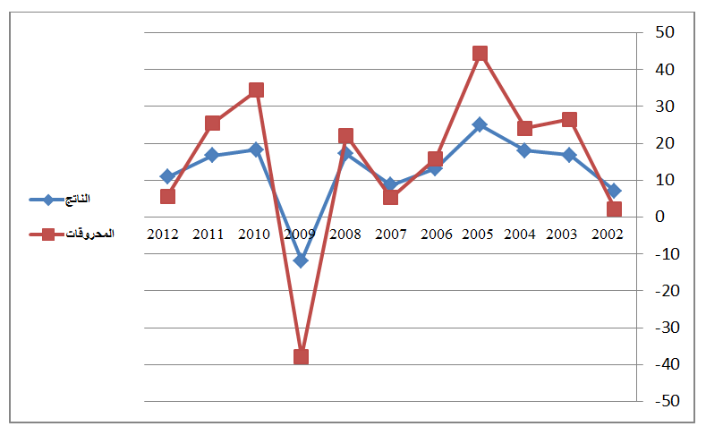

Source: author’s name, year, page

CONCLUSION
The conclusion of a research paper needs to summarize the content and purpose of the article. The conclusion of a research paper needs to summarize the content and purpose of the article. The conclusion of a research paper needs to summarize the content and purpose of the article. The conclusion of a research paper needs to summarize the content and purpose of the article. The conclusion of a research paper needs to summarize the content and purpose of the article. The conclusion of a research paper needs to summarize the content and purpose of the article.
(Sakkal Majalla14, interline 1.0)

Bibliography List: (Sakkal Majalla14, interline 1.0)
- Books Author/Authors: Book Title, Publisher, Country, Edition (Ed), Year, Part / Volume, p.
- Thesis and dissertations: Thesis/Dissertation Title, Master/PhD Thesis/Dissertation, Faculty and University, Year, Part, p.
Articles: Author/Authors: The title of the article, the name of the magazine, the issuer, the volume, the number, the year,Page.
- Conference paper: Author/Author(s): The title of the conference paper, name of the Conference, Place of Meeting, Date, P.
Legal documents: Article xx: Document Type (International Conventions, Constitution, Organic Law, Ordinary Law, Orders, Decrees, Regulations and Instructions...), Document Number, Date of Document, Content of Document, Official Gazette ), The number and date of issue, page/pages pp.
Judgments and judicial decisions: The judicial body issuing the judgment/decision, the chamber of jurisdiction (of the social, criminal, civil, ...), file number, date of judgment / decision, mention of the parties to the dispute, the source of the decision.
Websites :- Author name, full file address, detailed location (URL), browsing history: (day, month, hour, minute).
6.References: (Sakkal Majalla12, interline 1.0)

The researcher in the writing of the article adopts a set of sources and bibliographic references and scientific honesty must be Review in a correct scientific systematic way, Research references are written in accordance with APA Sixth Edition, OR in a mechanical way within the last page of the article in an automatic way (References), and writes (Sakkal Majalla12, interline 1.0)

Appendices:
Important Notes
Work in accordance with the terms of publication in this journal:
The volume of the research article should not exceed 25 pages, and not be less than 15 pages.
The article should be edited according to a correct scientific methodology without hurting, offending or discriminating and respecting the ideas undertaken.
The researcher is committed to scientific objectivity and authenticity in the preparation of his research.
The researcher is committed to the scientific secretariat in editing an article and respecting intellectual property rights.
The researcher is obliged to respect the template of the Review under the penalty of rejecting the article formally if it does not conform to the conditions
Formality and editing according to the exact dimensions of the page
The article is edited and sent to the editor-in-chief of Journal of Scientific Development for Studies and Research (JSD)
Website: www.jsd.sdevelopment4.com
Email: jsd@sdevelopment4.com

* *المؤلف المرسل.
* Corresponding author.

